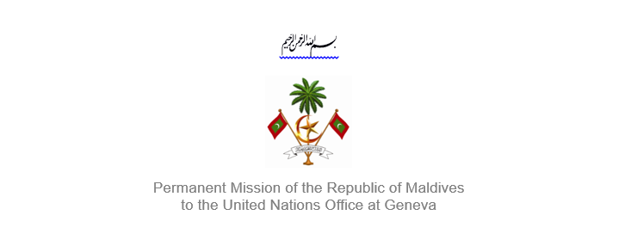25th Session of the Working Group of the Universal Periodic Review
2 – 13 May 2016, Geneva

Review of Trinidad and Tobago
10 May 2016

Statement by Ms. Rishfa Rasheed, Counsellor.
Permanent Mission of Maldives to the United Nations Office at Geneva

Check against delivery

Thank you, Mr. President,

The Maldives extends a warm welcome to the high level delegation from fellow Small Island Developing State (SIDS) Trinidad and Tobago to this review, led by His Excellency Mr, Eden Charles, Ambassador Extraordinary and Plenipotentiary, Chargé d’Affaires and Deputy Permanent Representative of Trinidad and Tobago to the United Nations.

The Maldives expresses its appreciation for today’s presentation, as well as the national report, and implementation of the recommendations Trinidad and Tobago received during its first cycle. We also welcome Trinidad and Tobago’s introduction of the 2012 Children Act that aims to ensure increased protection of children against sexual abuse. The Maldives also commends the efforts in enacting the Administration of Justice Act of 2012 that provides for the use of DNA information for forensic purposes.

The Maldives would like to make the following recommendations:

- Develop and implement a national awareness raising campaign on human rights

- Implement the updated National Policy on Persons with Disabilities

- Avail technical assistance from OHCHR towards implementation of its obligations under international law and treaties.

The Maldives appreciates the measures taken by Trinidad and Tobago to raise awareness concerning the trafficking of persons in the country.

Finally, we also take positive note of the Baby Care Assistance Initiative that aims at providing financial assistance for one year, for any child born to under-privileged parents during the course of the fiscal year.

We wish the delegation of Trinidad and Tobago all the success during this review.

Thank you Mr. President.

